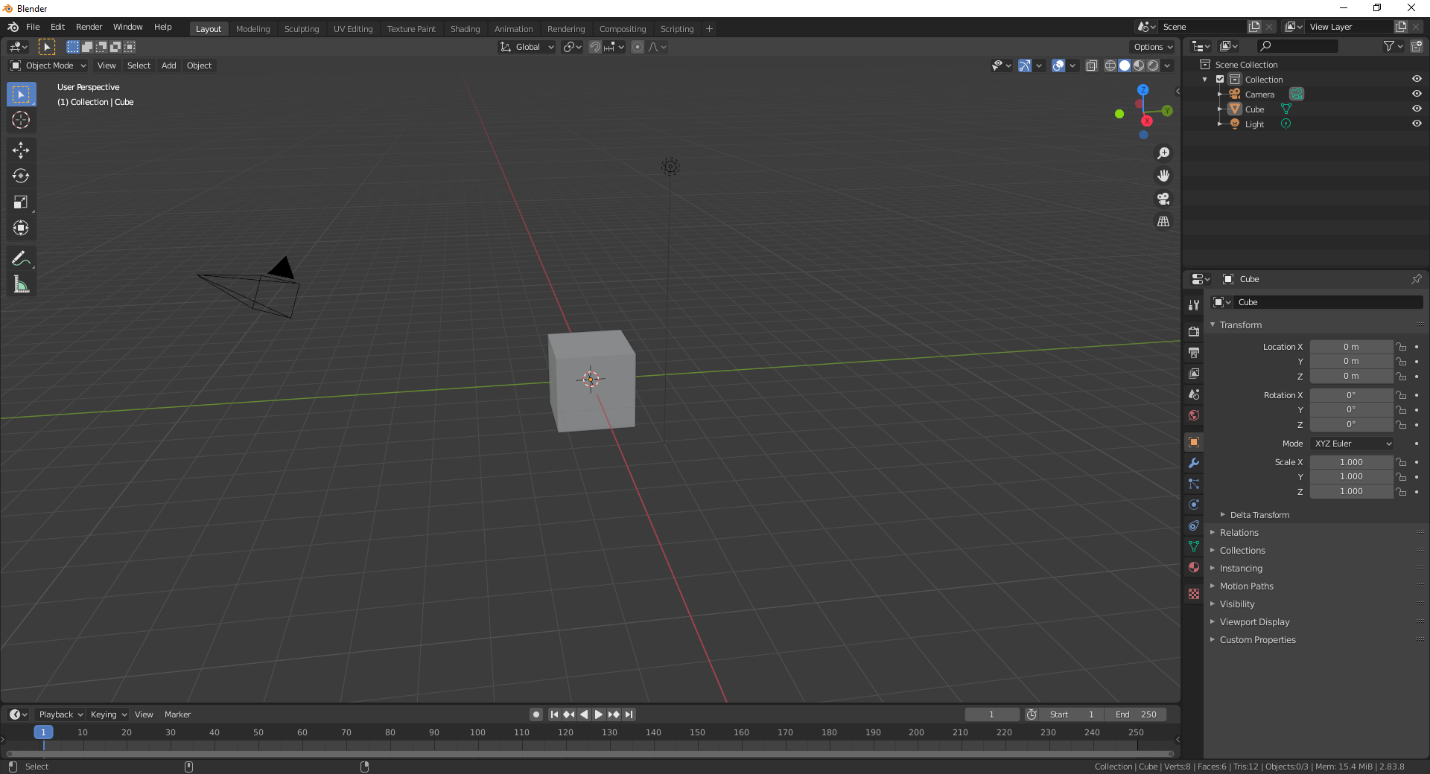

Zoom

Pan

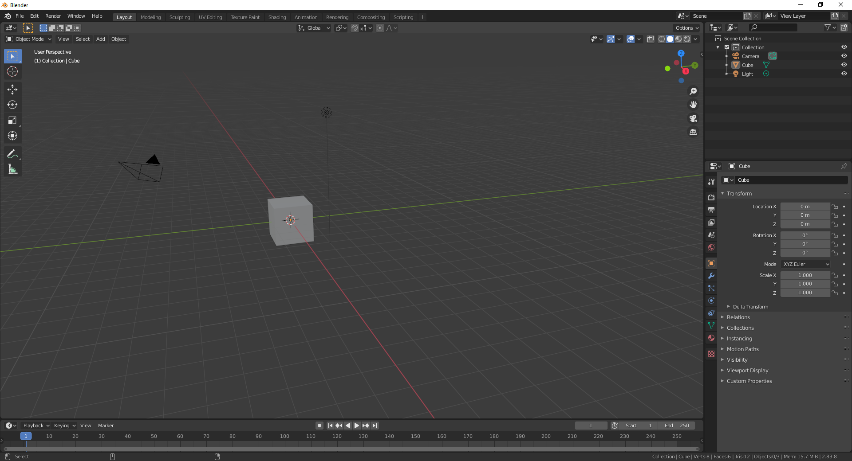

Can rename these

Lists everything on your screen

Collections = Groups (like layers in photoshop)

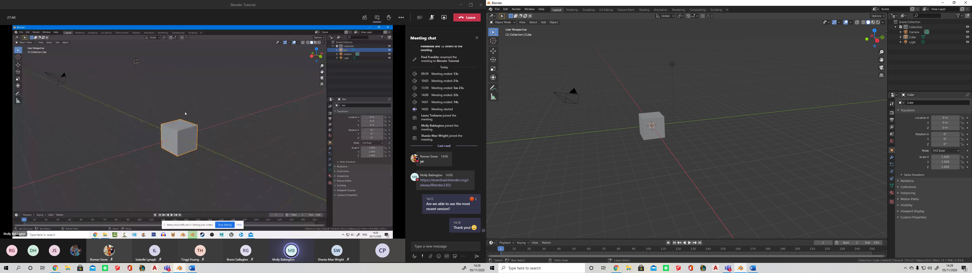

Different modes/styles of display

Wire, Solid, Texture and Render view

\*Render view - moving light makes effect

Axis – Same as SketchUp



Reverse order

Makes everything transparent

Viewpoint overlays – shows empty scene – without cameras etc

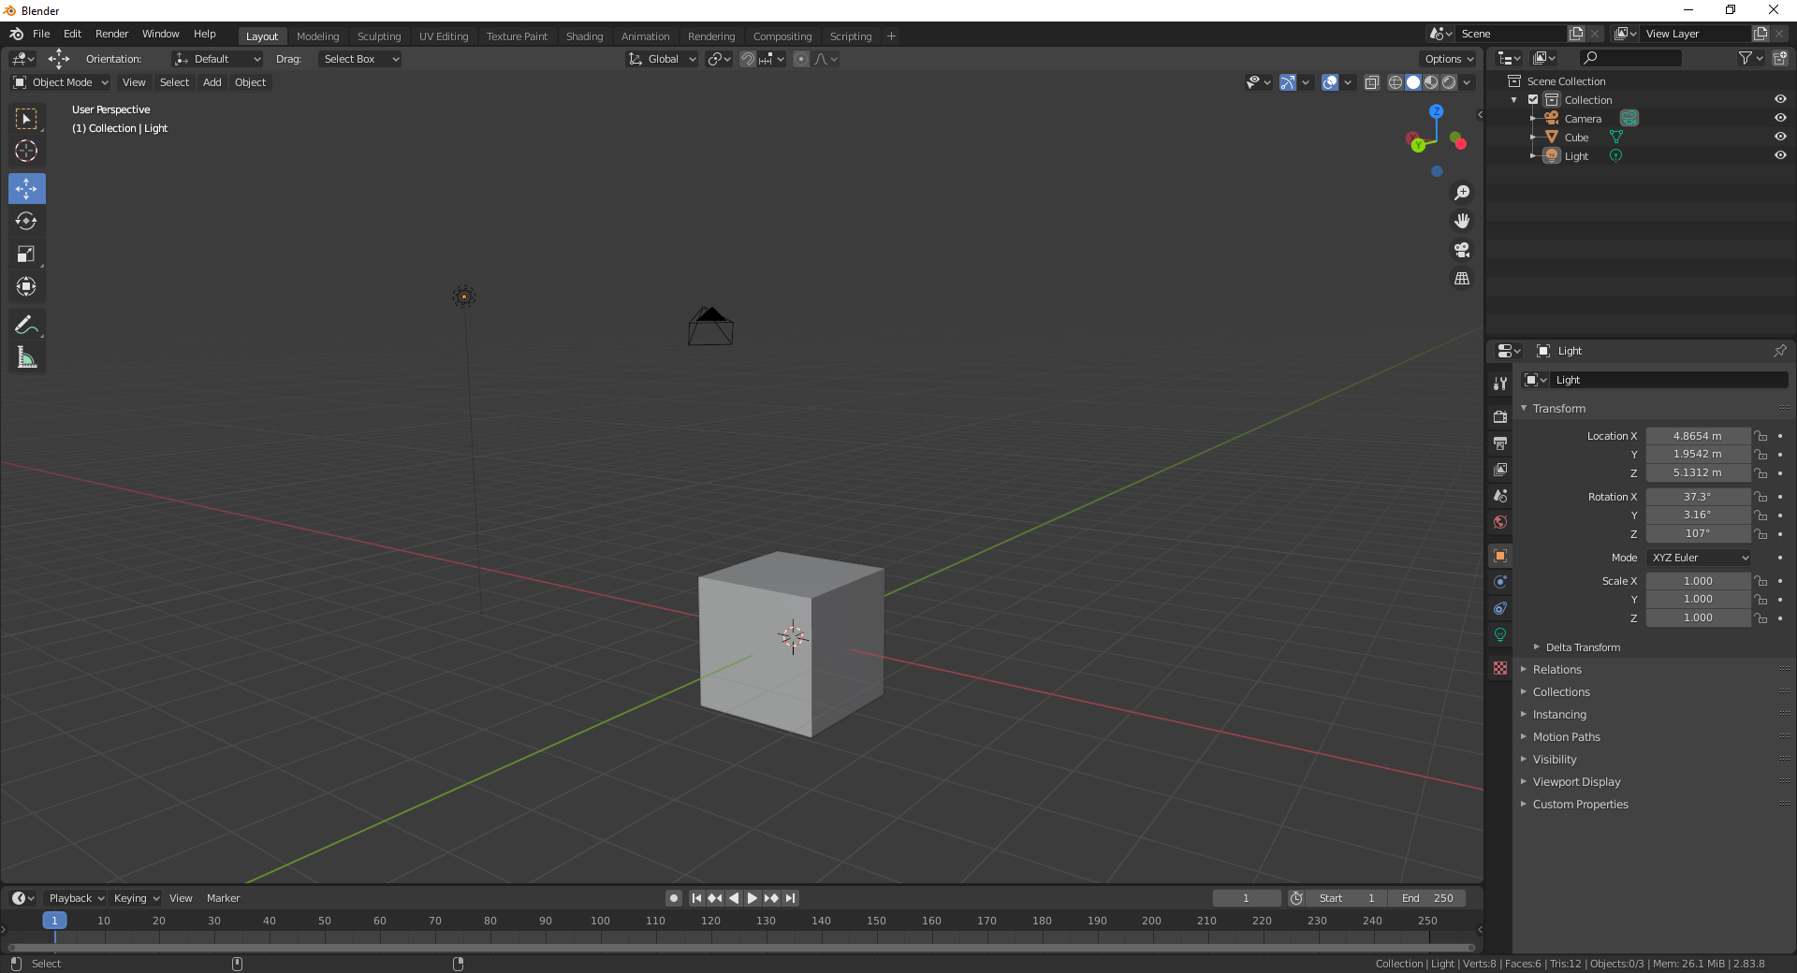

Click on object and use these

* Move
* Rotate
* Scale

Shortcuts

G – grab (left click yes, right click cancel)\*

R – Rotate \*

RR – Pivot \*

S = Scale \*

X or Y or Z – Locks to the axis (like arrow keys in sketchup

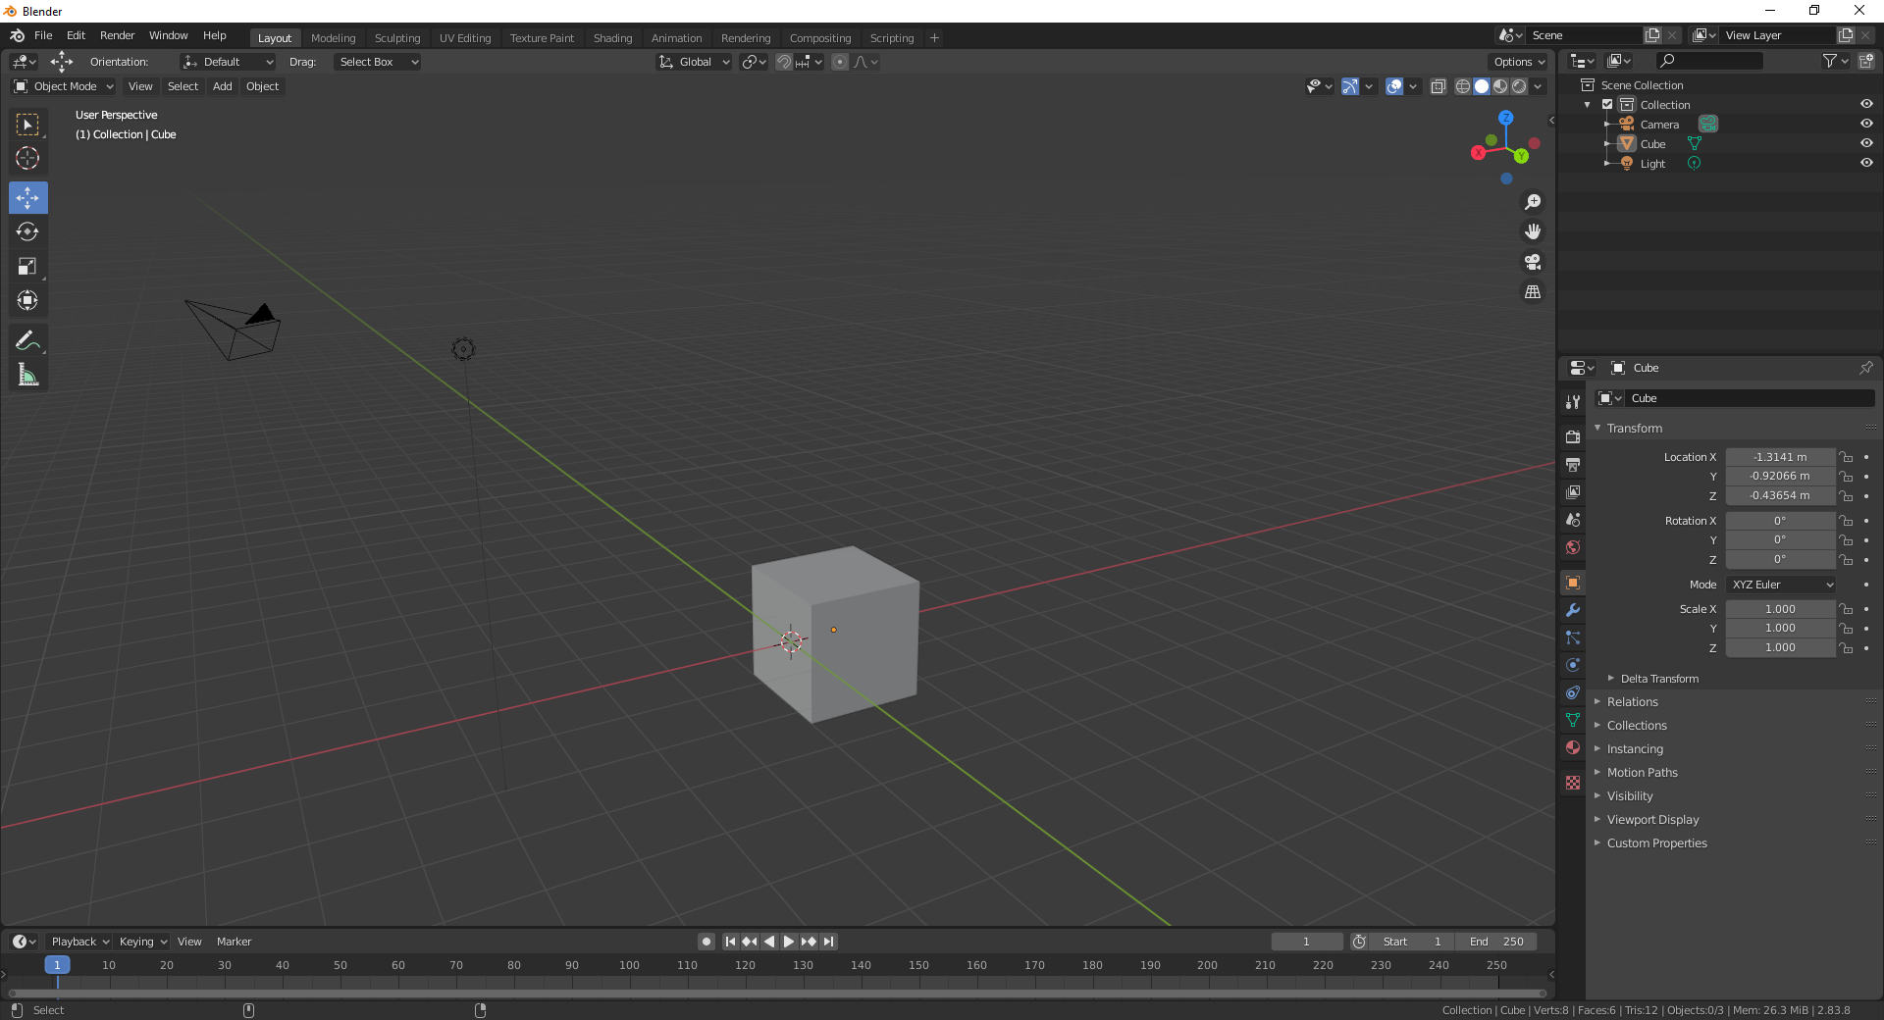

Properties

ALT G = Default Dimensions

ALT R = Default Dimensions

ALT S = Default Dimensions

Place Curser somewhere (Put to centre with shift C)

Click Add – mesh – shape

To delete = click object – click X or Delete

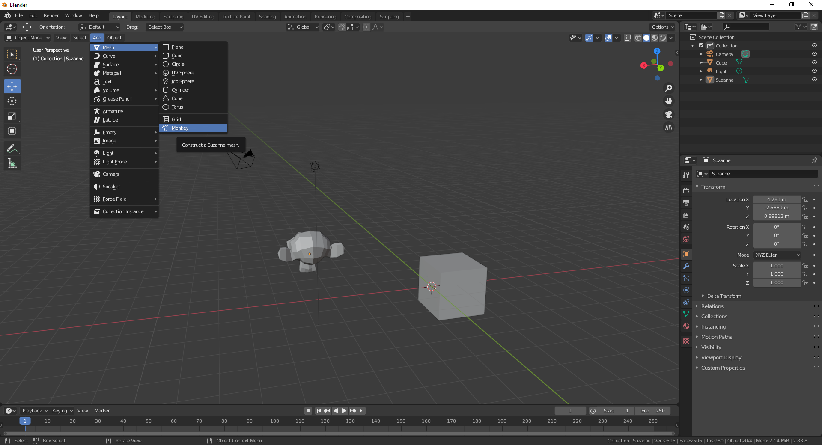

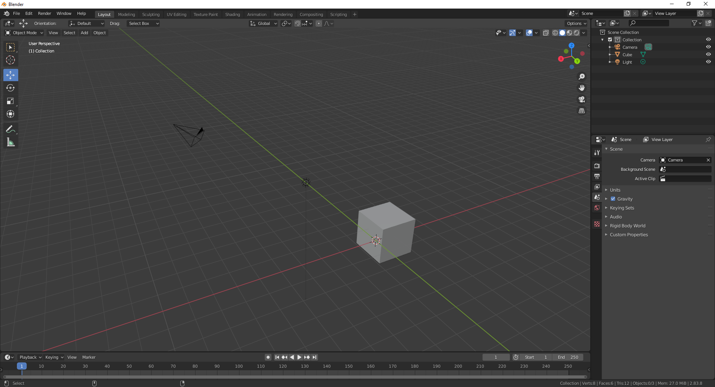

Different workspaces

Default = Layout

Can switch between them all

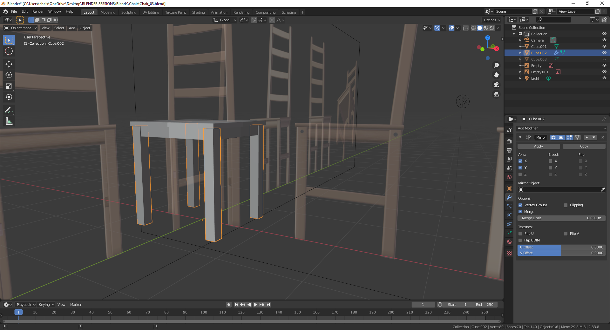

MODIFY  
Can mirror objects etc